
Student Name: RONNY MIRARA
Admission Number: BSCCS\2024\53811
Course: Bachelor of Science in Computer Science
Unit Code: BIT4139
Unit Name: ADVANCED CRYPTOGRAPHY
Lecturer Name: MR MICHAEL NYORO
Semester/Academic Year: SEM 2 YEAR 3
PROJECT TITLE: ADVANCED CRYPTOGRAPHIC PRACTICAL ACTIVITIES AND IMPLEMENTATION
TECHNOLOGIES USED : KALI LINUX SECURITY TOOLS , PYTHON
GitHub : https://github.com/Mirara007/advanced-cryptography-logbook

Contents
week 1 3
4
Week 2 7
Week 3 10
Week 4 13
WEEK 5 16

Figure 1 Installation of VS Code and python 3
Figure 2 Installation of cryptographic libraries 3
Figure 3 Open SSL Installation test 4
Figure 4 Local encryption script encryption 4
Figure 5 GitHub Repository Initialization 5
Figure 6 Caesar cipher implementation 6
Figure 7 vigenere cipher encryption process 6
Figure 8 Encryption and Decryption output 7
Figure 9 User input Validation Interface 7
Figure 10 cipher testing result 8
Figure 11 LSFR Generator Implementation 9
Figure 12 Pseudorandom Sequence Output 9
Figure 13 Statistical Random Testing 10
Figure 14 RC4 Stream Cipher Simulation 10
Figure 15 Encryption Performance Testing 11
Figure 16 AES Encryption Script 12
Figure 17 Key Generation Process 12
Figure 18 File Encryption Demonstration 13
Figure 19 Decryption Results 13
Figure 20 AES Performance Testing 14
Figure 21 RSA Key Pair Generation 15
Figure 22 Public Key Encryption Process 15
Figure 23 Private Key Decryption Results 16
Figure 24 Secure Message Transmission 16
Figure 25 RSA Testing And Validation 17

week 1

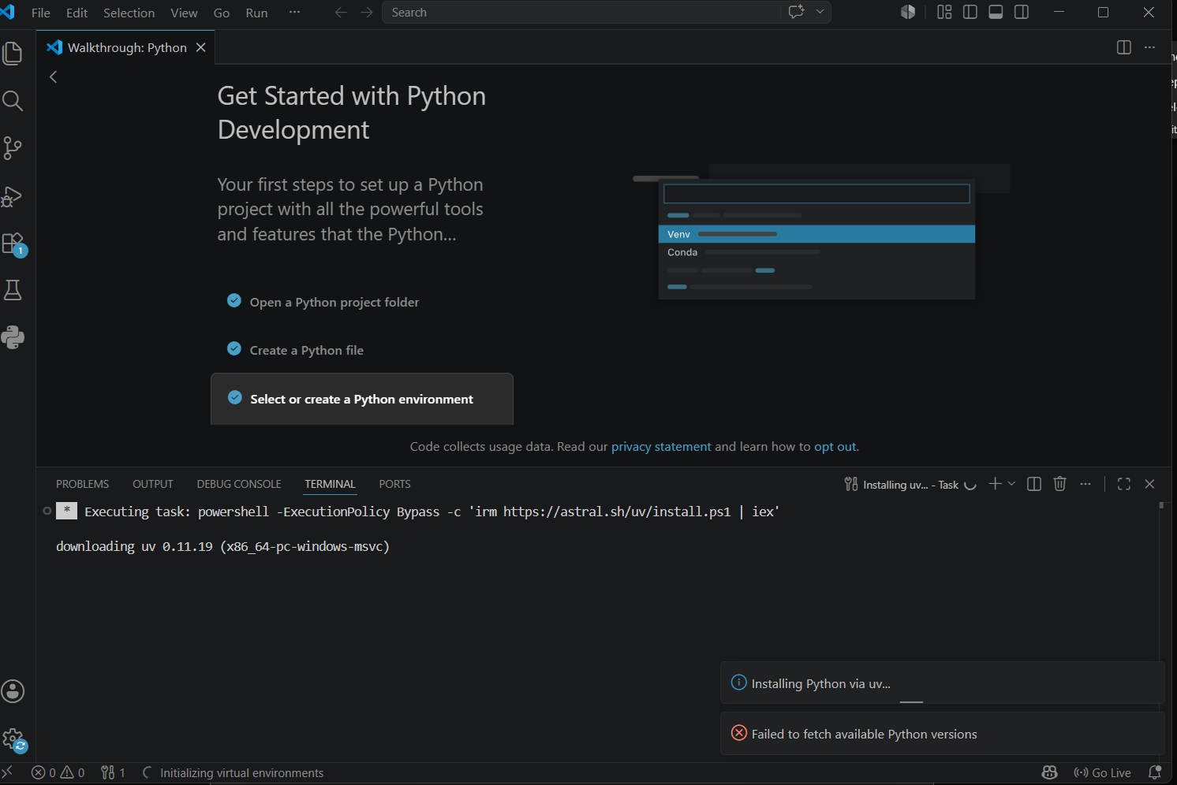
Figure 1 Installation of VS Code and python
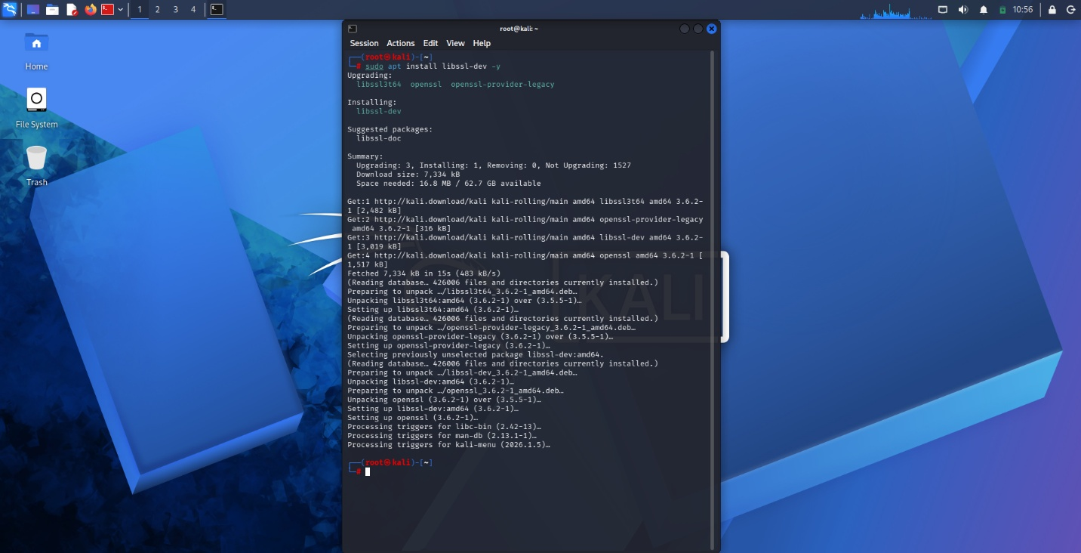
Figure 2 Installation of cryptographic libraries
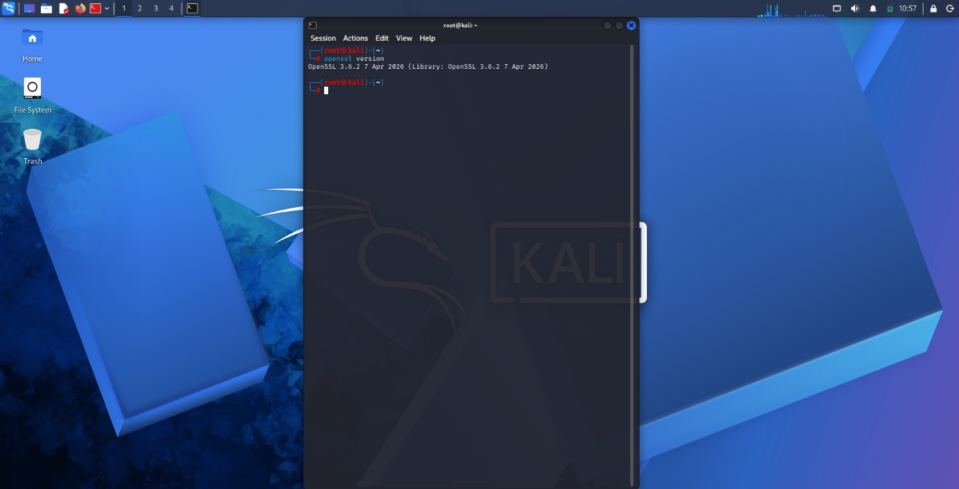
Figure 3 Open SSL Installation test
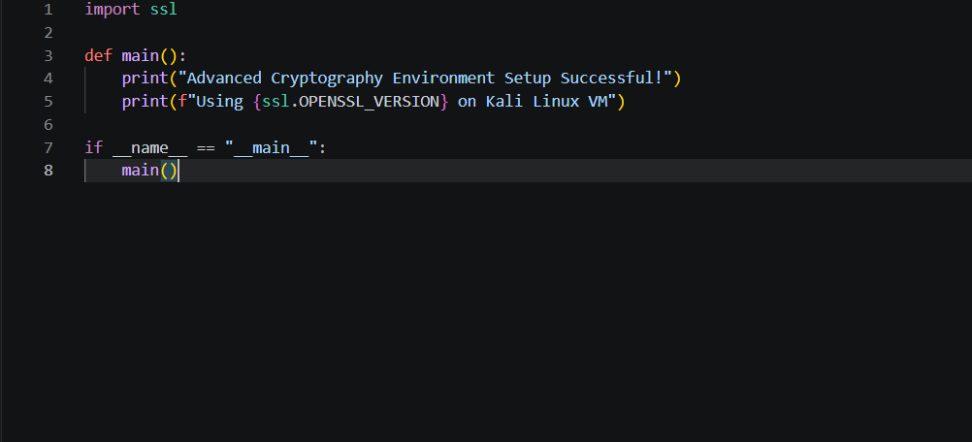
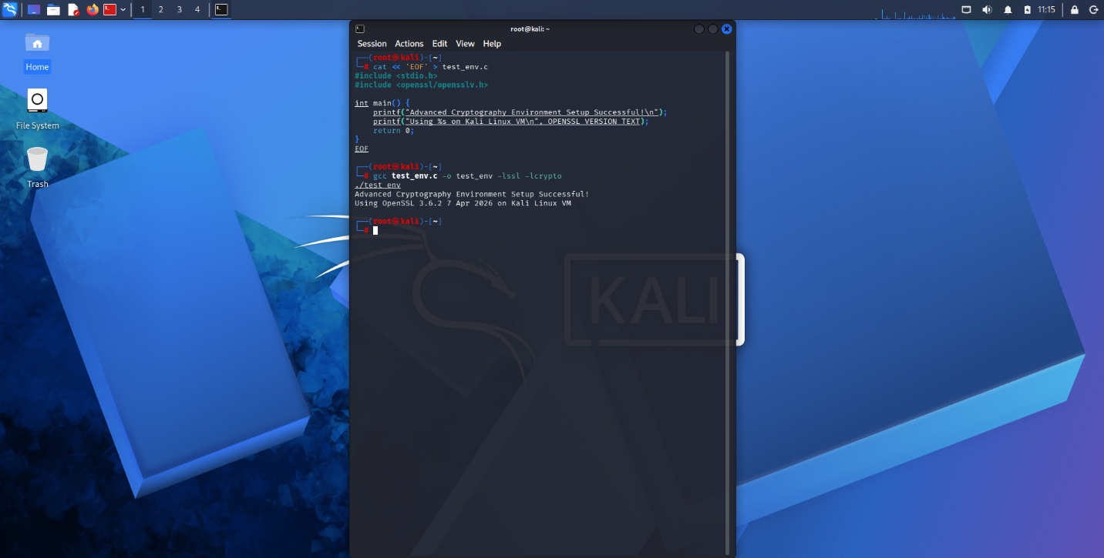
Figure 4 Local encryption script encryption
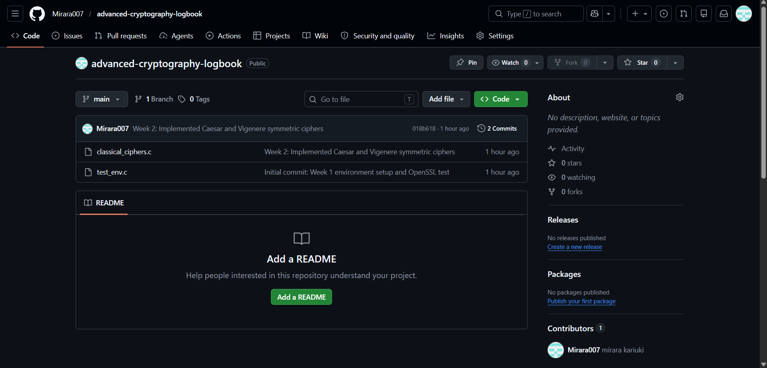
Figure 5 GitHub Repository Initialization

Student Reflection
Established a secure programming environment on Kali Linux, integrating OpenSSL libraries for advanced cryptography. confirm compiler and library setup alongside successful script execution documents GitHub version control initialization, ensuring all portfolio code is accurately tracked and securely managed.

Week 2

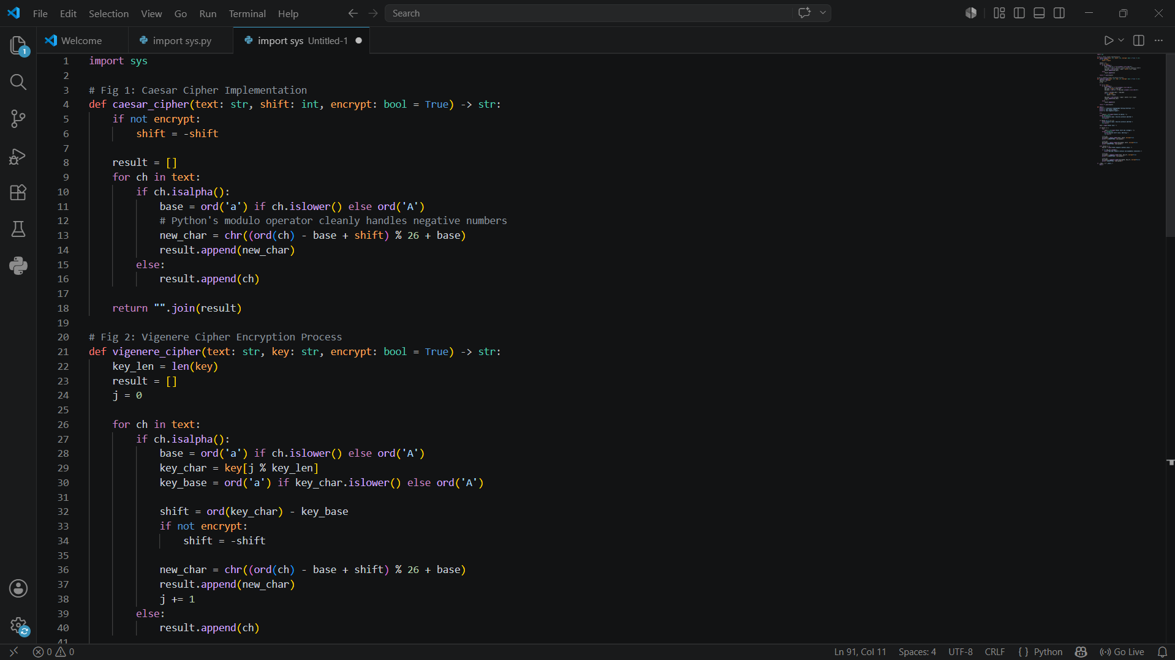
Figure 6 Caesar cipher implementation


Figure 7 Vigenère cipher encryption process
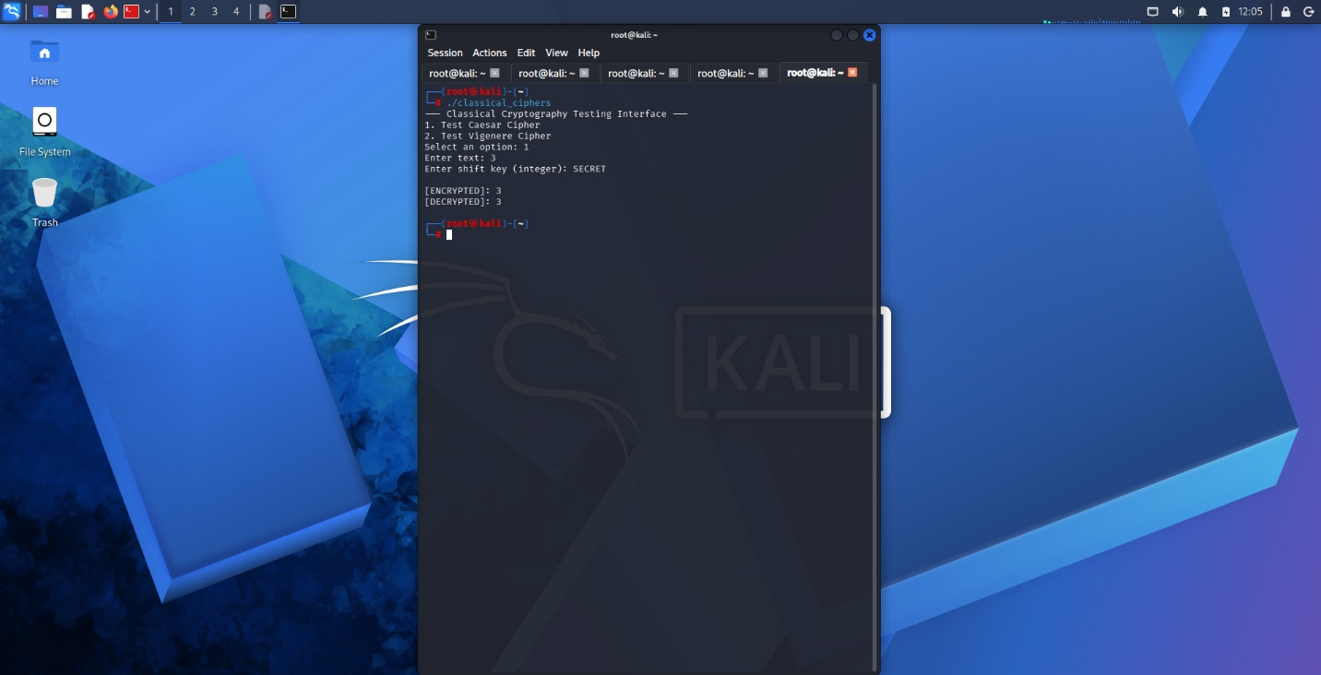
Figure 8 Encryption and Decryption output
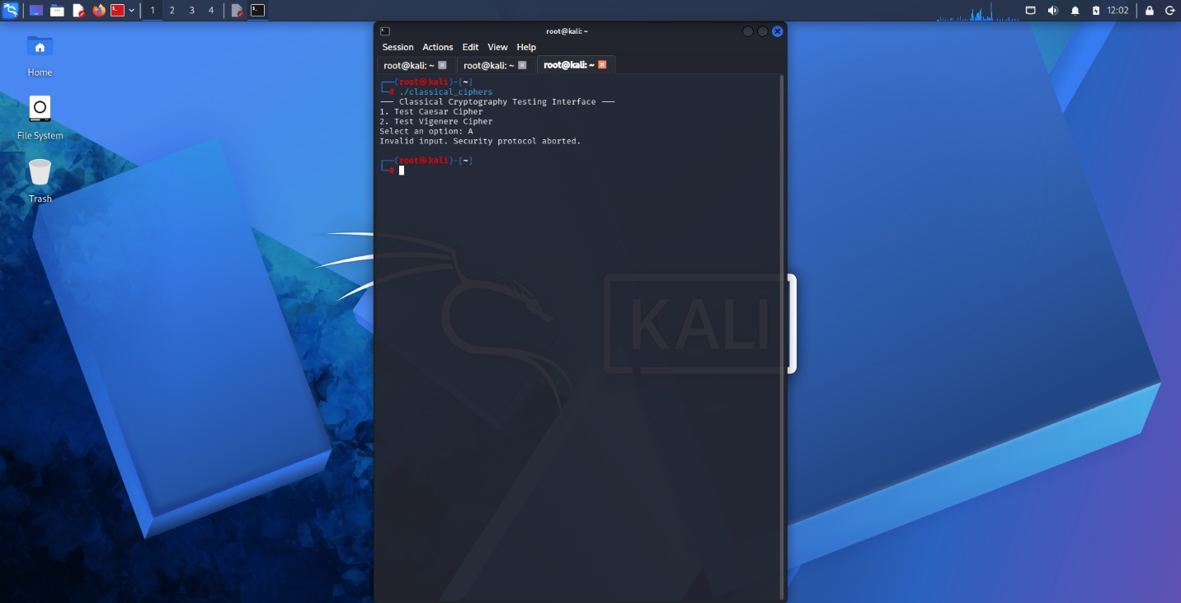
Figure 9 User input Validation Interface

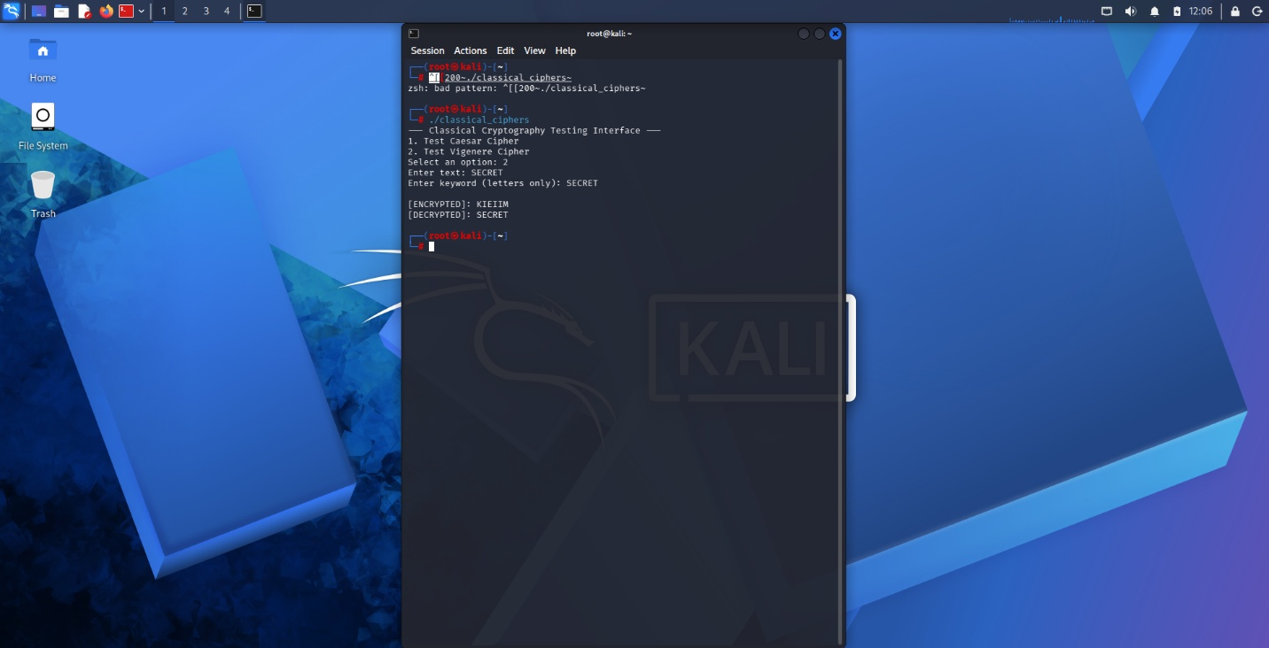
Figure 10 cipher testing result
Student Reflection
Developed Caesar and Vigenère ciphers , demonstrating foundational symmetric encryption and validation logic . While Vigenère improves upon Caesar’s single-shift vulnerability, both historical algorithms lack modern complexity. This highlights the critical necessity for mathematically unpredictable, large key spaces in secure systems.

Week 3


Figure 11 LSFR Generator Implementation
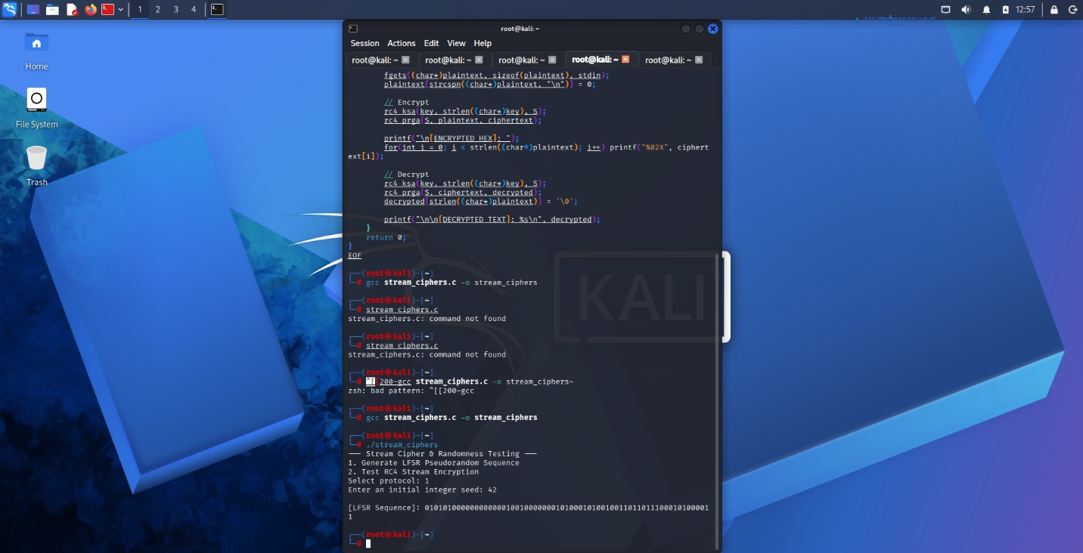
Figure 12 Pseudorandom Sequence Output

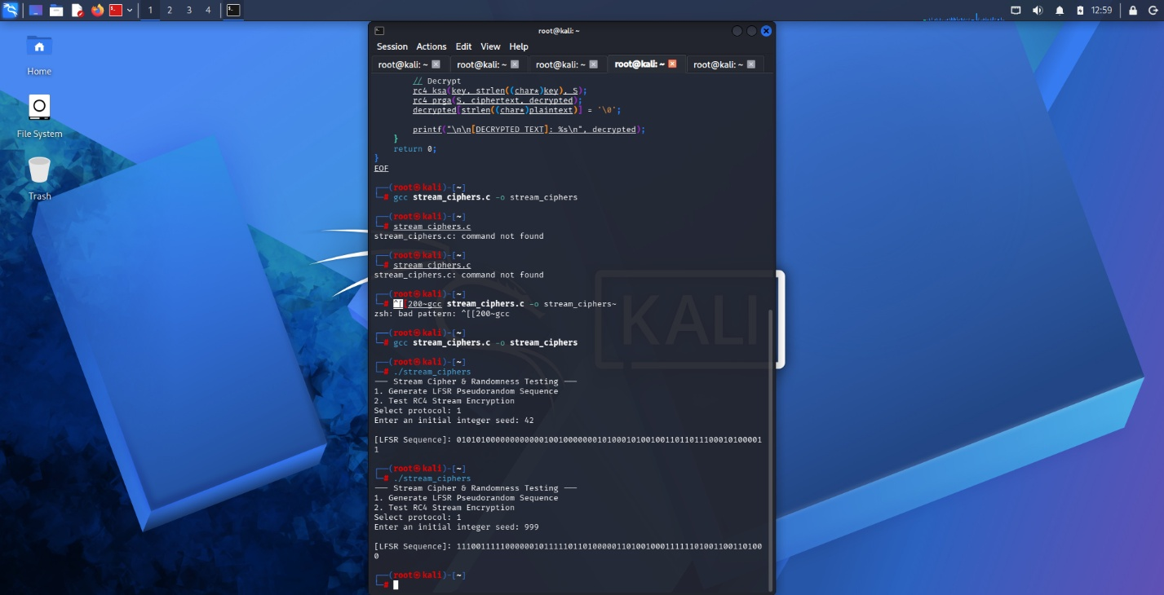
Figure 13 Statistical Random Testing


Figure 14 RC4 Stream Cipher Simulation

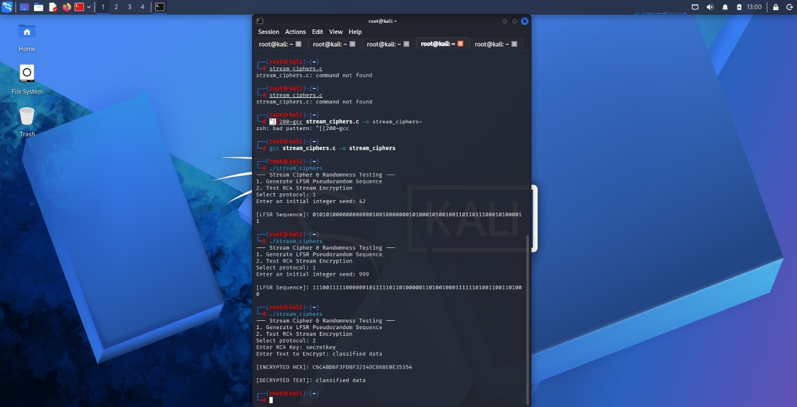
Figure 15 Encryption Performance Testing
Student reflection
Developed an LFSR generator and RC4 stream cipher. Demonstrated pseudorandom bit generation and real-time XOR encryption. These implementations highlight the critical need for mathematically sound randomness to prevent predictable patterns and vulnerabilities in continuous data streams.

Week 4
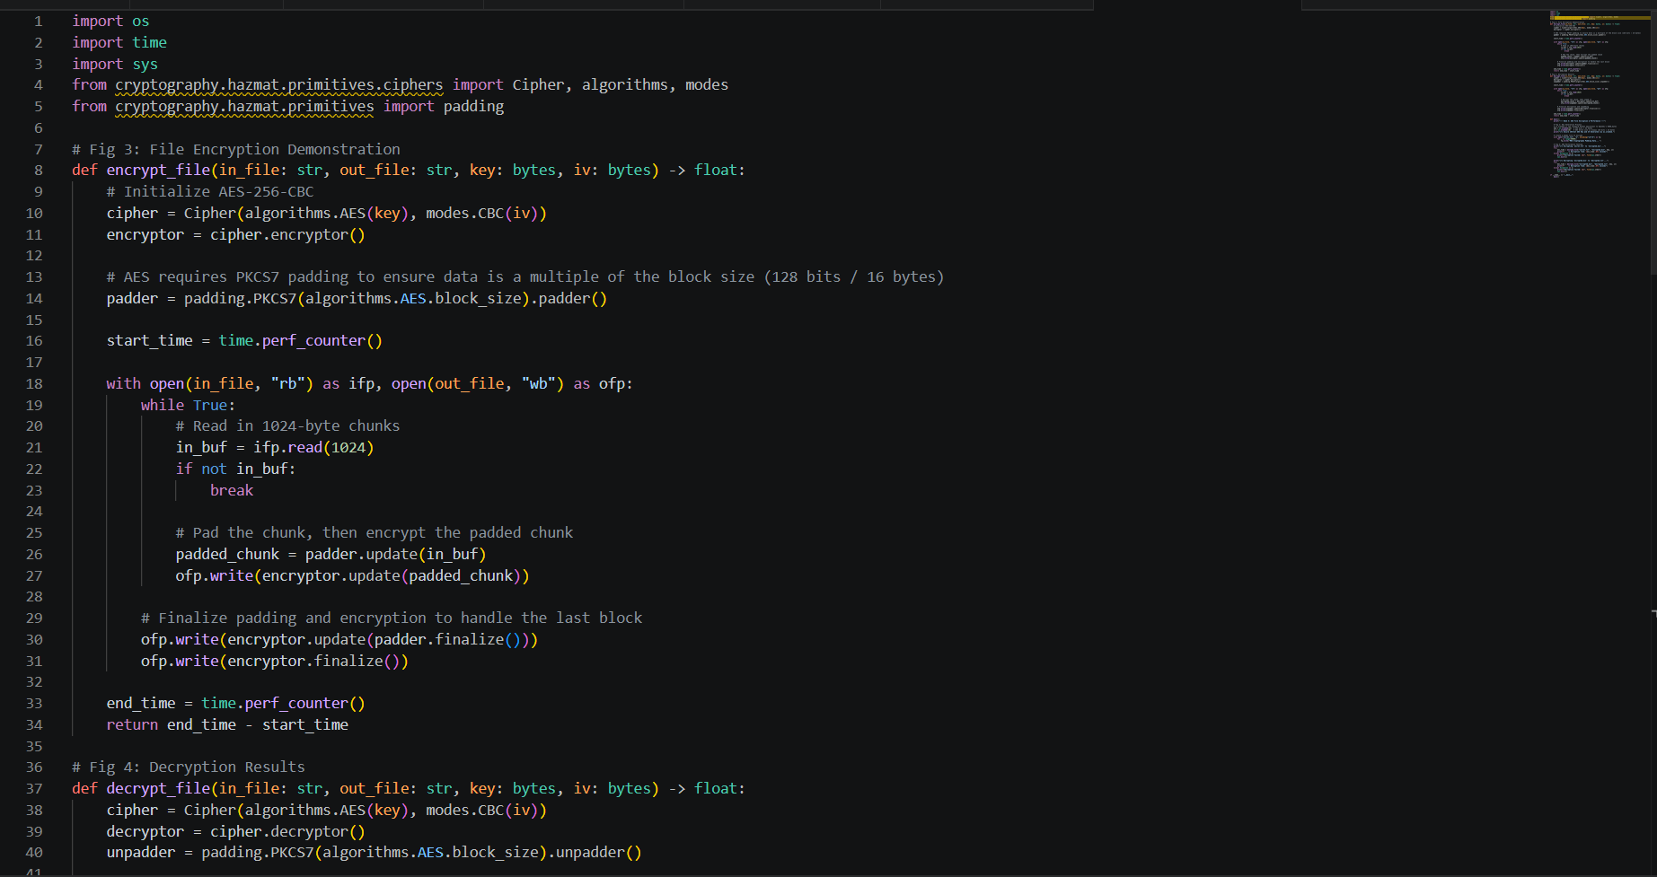
Figure 16 AES Encryption Script
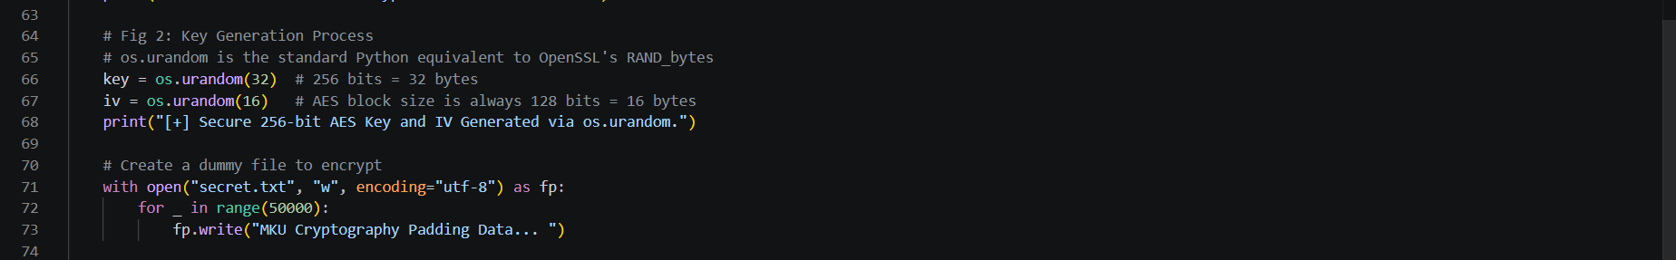
Figure 17 Key Generation Process
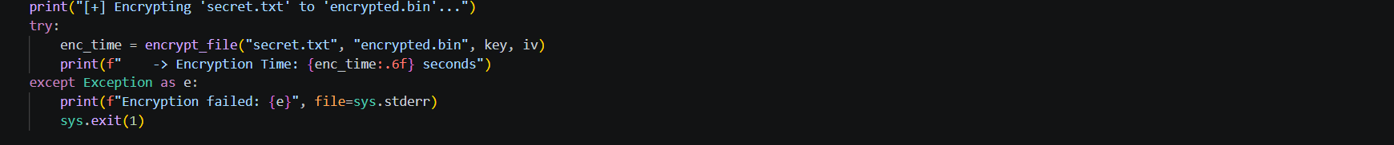
Figure 18 File Encryption Demonstration
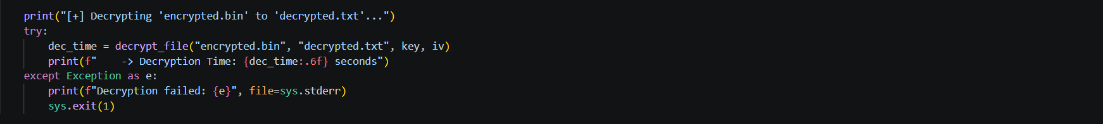
Figure 19 Decryption Results

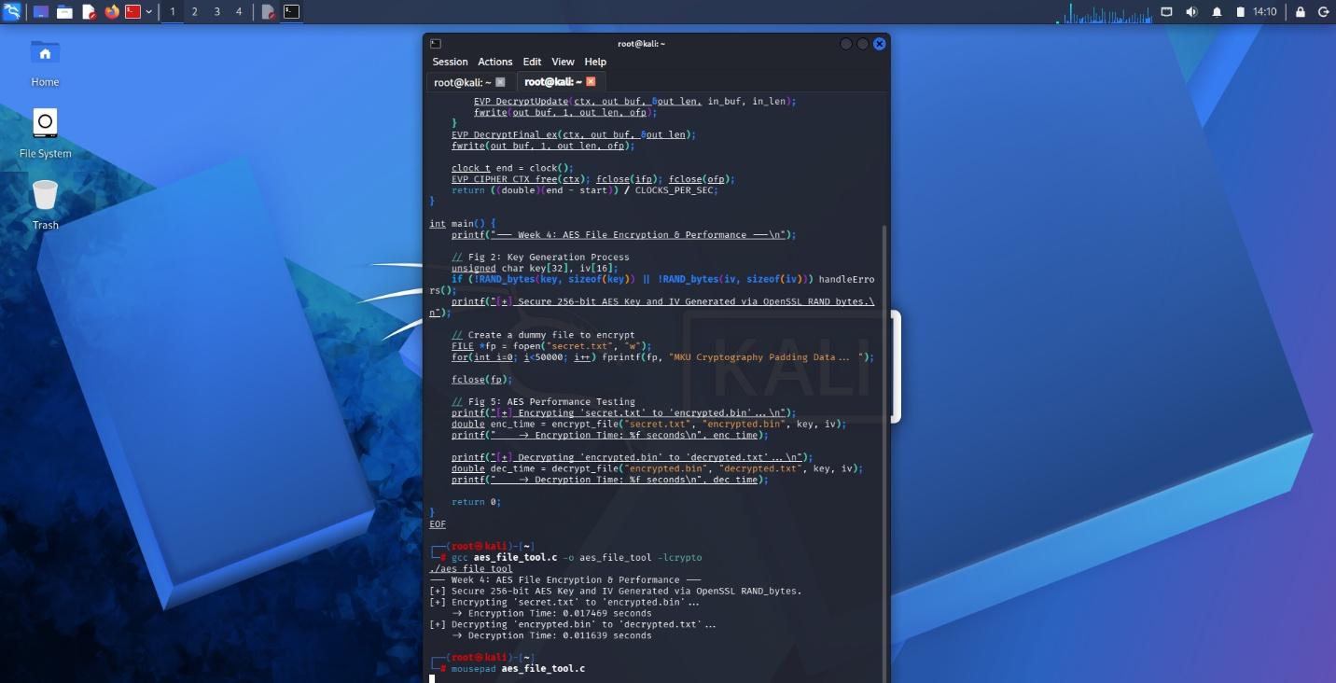
Figure 20 AES Performance Testing
Student Reflection
Developed utilizing OpenSSL to securely generate a 256-bit AES key (RAND_bytes) and encrypt/decrypt text files. Performance testing confirmed AES's high-speed processing capabilities. A primary implementation challenge was safely managing memory buffers during the EVP file stream operations to ensure complete, uncorrupted data recovery.

WEEK 5

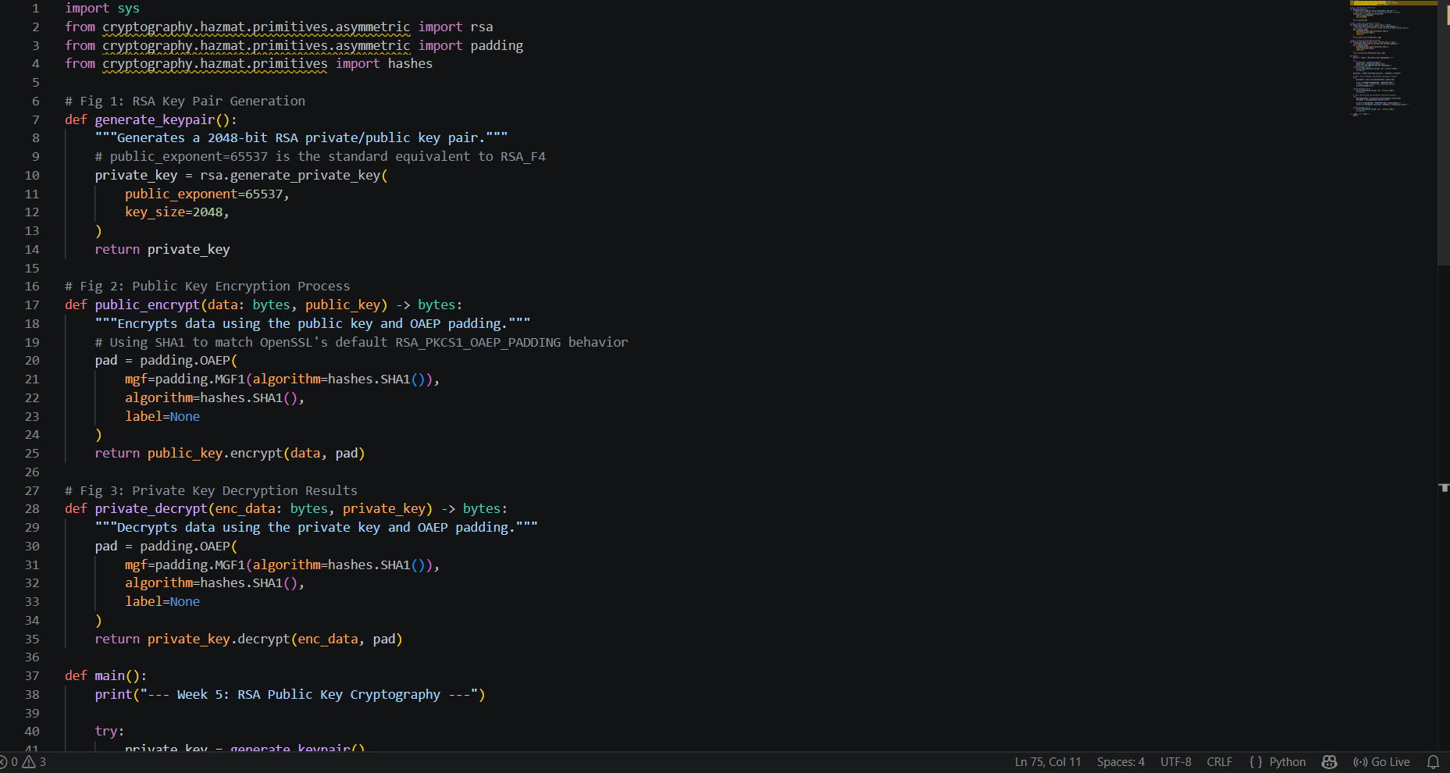
Figure 21 RSA Key Pair Generation

Figure 22 Public Key Encryption Process

Figure 23 Private Key Decryption Results

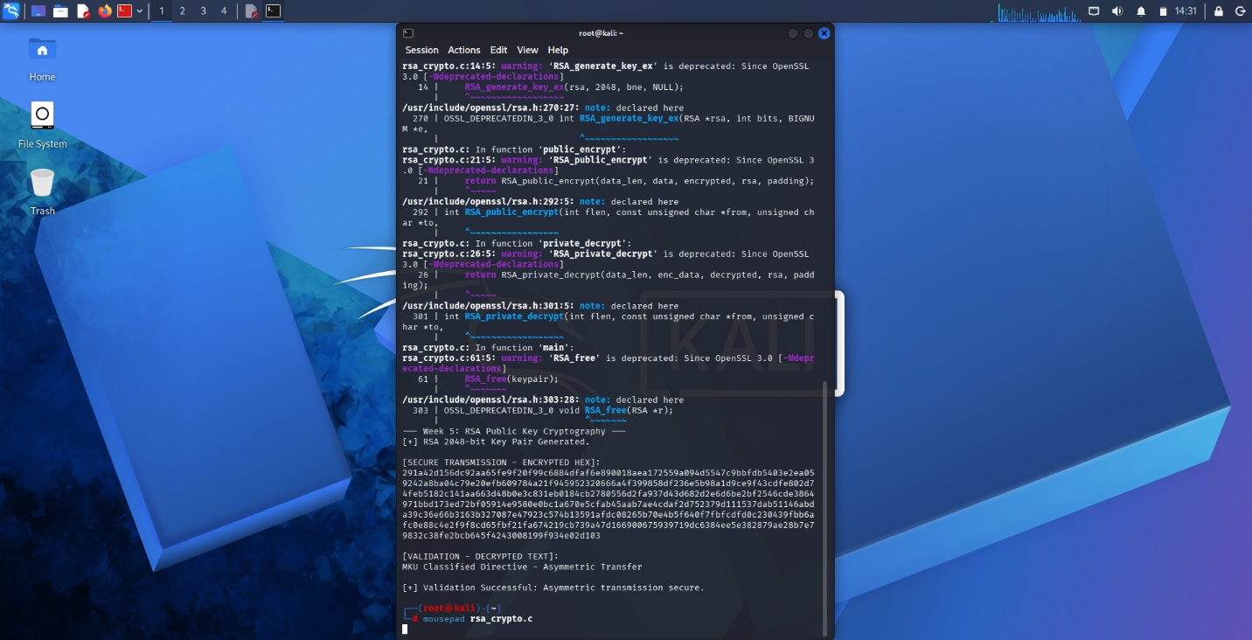
Figure 24 Secure Message Transmission


Figure 25 RSA Testing And Validation
Student Reflection
Unlike symmetric systems, asymmetric RSA utilizes distinct public and private keys, solving secure key distribution. The public key securely encrypts data for transmission, while only the private key performs decryption. Testing validated this workflow, confirming robust data confidentiality and integrity without risking key interception.

